**3.2.2 Number of workshops/seminars conducted on Research Methodology, Intellectual Property Rights (IPR) and entrepreneurship during the year**

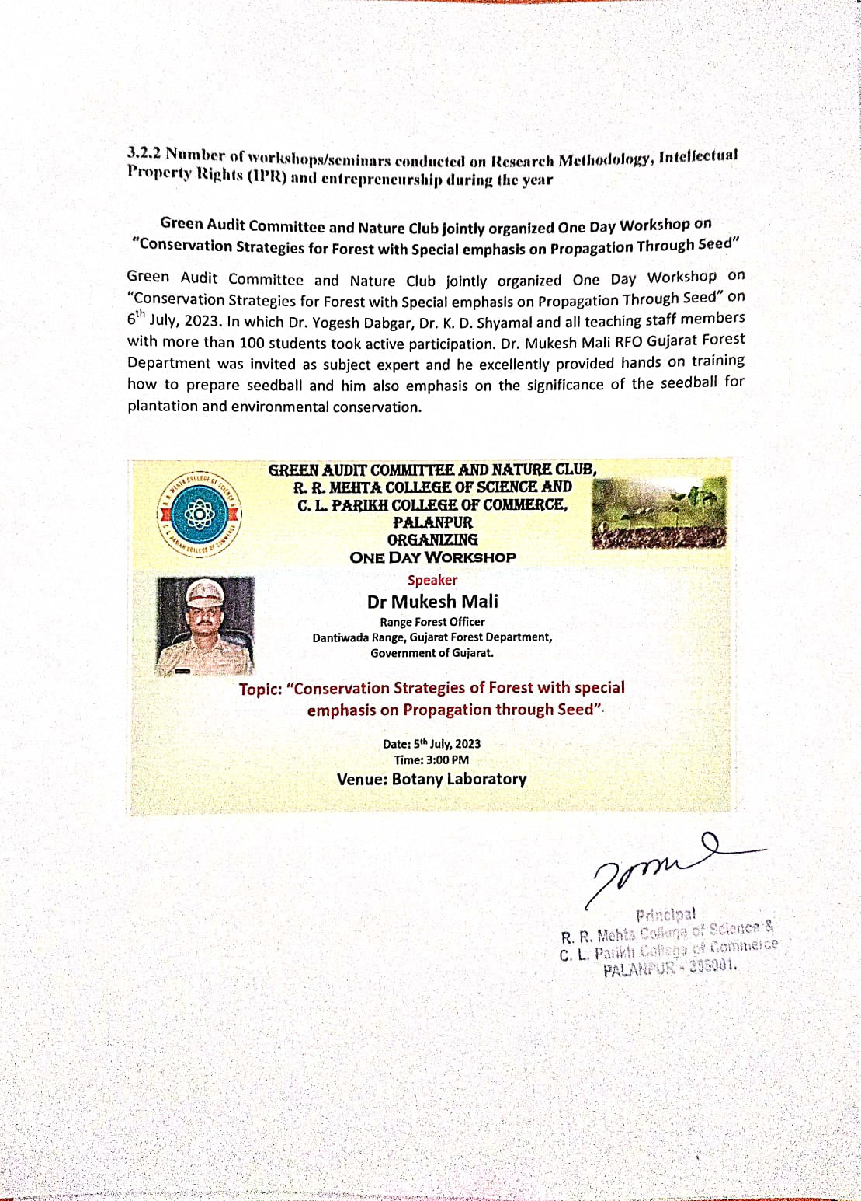**One day workshop on Conservation strategies for forest with special emphasis on propogation through Seeds**